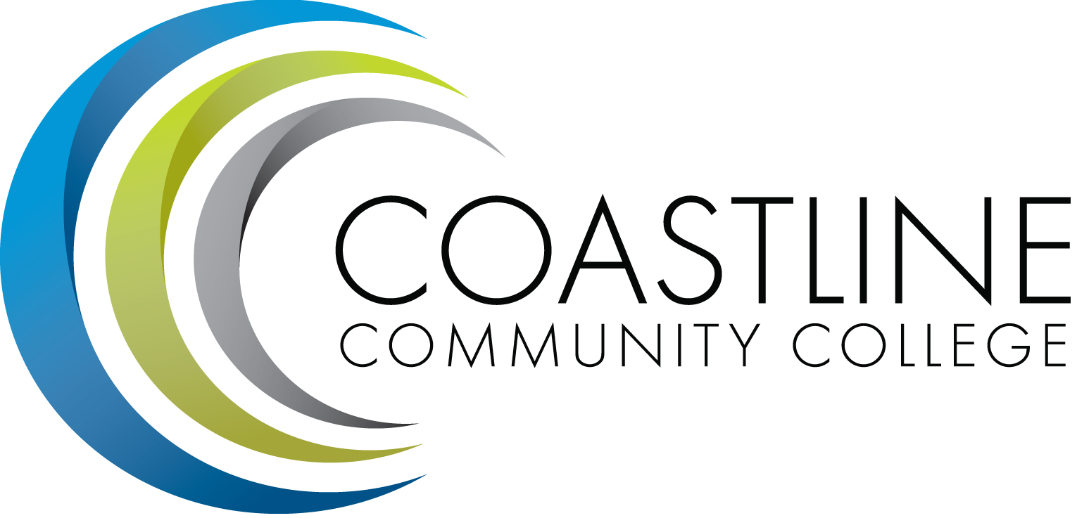

Budget Committee
Wednesday, April 25, 2018
1:00 p.m. – 3:00 p.m.
College Center – Fourth Floor Conference Room
AGENDA
Committee Mandate: To identify resource allocation based on the mission, plans, and goals of the college as articulated in the Education Master Plan (EMP) and as developed and recommended by the Planning, Institutional Effectiveness and Accreditation (PIEAC) committee.

CALL TO ORDER
  - Welcome
  - Adoption of Agenda
  - Approval of Minutes: March 14, 2018

REPORTS
  - Self-Study Report for Standard IIID – H. Rothgeb
  - Financial Plan – C. Nguyen

DISCUSSION
  - Budget Model Discussion – C. Nguyen
  - 2018/19 Budget Development – C. Nguyen
  - 2018/19 Schedule Maintenance Program/ State Funded Equipment Allocation – C. Nguyen

ACTION
  - Follow-Up on Action Items from March 14, 2018 meeting:
    - Non-Credit and Enhanced Non-Credit Courses Listing – V. Rodriguez

STANDING REPORTS

ANNOUNCEMENTS

ADJOURNMENT
Next Meeting: May 9, 2018, 1:00-3:00 p.m., CCC 4th Floor Conference Room

Attachment provided via email and at meeting

